

LAB Assignment #03
OOP
Instructor: Mr. Mohsin Ahmed

Student Name: |  | Muhammad Abdullah
Registration No: |  | FA24-BSE-042
Department: |  | SOFTWARE ENGINEERING
Submission Date: |  | 27 November 2025

  - COMSATS University Islamabad

Lab Task 1
Write a program that uses an ArrayList of parameter type Contact to store a database of contacts.
The Contact class should store the contact’s first and last name, phone number, and email address.
Add appropriate accessor and mutator methods. Your database program should present a menu that
allows the user to add a contact, display all contacts, search for a specific contact and display it,
or search for a specific contact and give the user the option to delete it.

The searches should find any contact where any instance variable contains a target search string.
For example, if “elmore” is the search target, then any contact where the first name, last name,
phone number, or email address contains “elmore” should be returned for display or deletion.

Use the “for-each” loop to iterate through the ArrayList.

Code:

import java.util.*;

class Contact {
private String firstName;
private String lastName;
private String phone;
private String email;

public Contact(String firstName, String lastName, String phone, String email) {
this.firstName = firstName;
this.lastName = lastName;
this.phone = phone;
this.email = email;
}

public String getFirstName() { return firstName; }
public String getLastName() { return lastName; }
public String getPhone() { return phone; }
public String getEmail() { return email; }

@Override
public String toString() {
return firstName + " " + lastName + " | Phone: " + phone + " | Email: " + email;
}
}

public class LabTask1 {
public static void main(String[] args) {

Scanner sc = new Scanner(System.in);
ArrayList<Contact> list = new ArrayList<>();

while (true) {
System.out.println("\n--- CONTACT MENU ---");
System.out.println("1. Add Contact");
System.out.println("2. Display All Contacts");
System.out.println("3. Search Contact");
System.out.println("4. Search and Delete Contact");
System.out.println("5. Exit");
System.out.print("Choice: ");
int ch = sc.nextInt(); sc.nextLine();

if (ch == 1) {
System.out.print("First Name: "); String fn = sc.nextLine();
System.out.print("Last Name: "); String ln = sc.nextLine();
System.out.print("Phone: "); String ph = sc.nextLine();
System.out.print("Email: "); String em = sc.nextLine();
list.add(new Contact(fn, ln, ph, em));
}
else if (ch == 2) {
for (Contact c : list)
System.out.println(c);
}
else if (ch == 3) {
System.out.print("Search keyword: ");
String key = sc.nextLine().toLowerCase();
for (Contact c : list) {
if (c.getFirstName().toLowerCase().contains(key) ||
c.getLastName().toLowerCase().contains(key) ||
c.getPhone().contains(key) ||
c.getEmail().toLowerCase().contains(key)) {
System.out.println(c);
}
}
}
else if (ch == 4) {
System.out.print("Keyword to delete: ");
String key = sc.nextLine().toLowerCase();
Contact found = null;

for (Contact c : list) {
if (c.getFirstName().toLowerCase().contains(key) ||
c.getLastName().toLowerCase().contains(key) ||
c.getPhone().contains(key) ||
c.getEmail().toLowerCase().contains(key)) {
found = c; break;
}
}

if (found != null) {
System.out.println("Found: " + found);
System.out.print("Delete? (y/n): ");
if (sc.next().charAt(0) == 'y')
list.remove(found);
} else {
System.out.println("Not found.");
}
}
else break;
}
sc.close();
}
}
Lab Task 2
Write a generic class, MyMathClass, with a type parameter T where T is a numeric object
type (Integer, Double, or any class that extends Number). Add a method standardDeviation that
takes an ArrayList<T> and returns the standard deviation as a double. Use doubleValue() to convert.

The program should produce a compile-time error if non-numeric types are used.

Code:

import java.util.*;

class MyMathClass<T extends Number> {

public double standardDeviation(ArrayList<T> list) {
int n = list.size();
if (n == 0) return 0;

double sum = 0;
for (T x : list)
sum += x.doubleValue();
double mean = sum / n;

double vsum = 0;
for (T x : list)
vsum += Math.pow(x.doubleValue() - mean, 2);

return Math.sqrt(vsum / n);
}
}

public class LabTask2 {
public static void main(String[] args) {

ArrayList<Integer> nums = new ArrayList<>();
nums.add(10); nums.add(12); nums.add(23);
nums.add(23); nums.add(16); nums.add(23);
nums.add(21); nums.add(16);

MyMathClass<Integer> obj = new MyMathClass<>();
System.out.println("Standard Deviation: " + obj.standardDeviation(nums));
}
}

Lab Task 3
Create a generic class with a type parameter that simulates drawing an item at random out of a box.
The box may contain Strings, Integers, etc. Provide:
- add(item)
- isEmpty()
- drawItem() → returns a random item or null if empty

Write a main method to test the class.

Code:

import java.util.*;

class RandomBox<T> {
private ArrayList<T> items = new ArrayList<>();
private Random rd = new Random();

public void add(T item) {
items.add(item);
}

public boolean isEmpty() {
return items.isEmpty();
}

public T drawItem() {
if (isEmpty()) return null;
return items.get(rd.nextInt(items.size()));
}
}

public class LabTask3 {
public static void main(String[] args) {

RandomBox<String> names = new RandomBox<>();
names.add("Ali");
names.add("Sara");
names.add("Usman");

System.out.println("Random Name: " + names.drawItem());

RandomBox<Integer> nums = new RandomBox<>();
nums.add(5);
nums.add(10);
nums.add(20);

System.out.println("Random Number: " + nums.drawItem());
}
}

/*
Lab Task 4
In diving, 7 judges give scores (0–10). Highest and lowest are removed.
Remaining 5 scores are summed. Total score = sum × degreeOfDifficulty × 0.6.
Store scores in an ArrayList<Double>. Input difficulty and 7 scores, output final score.

Code:

import java.util.*;

public class LabTask4 {
public static void main(String[] args) {

Scanner sc = new Scanner(System.in);
ArrayList<Double> scores = new ArrayList<>();

System.out.print("Enter degree of difficulty (1.2 - 3.8): ");
double diff = sc.nextDouble();

System.out.println("Enter 7 judges' scores:");
for (int i = 0; i < 7; i++)
scores.add(sc.nextDouble());

double max = Collections.max(scores);
double min = Collections.min(scores);

scores.remove(max);
scores.remove(min);

double sum = 0;
for (double d : scores)
sum += d;

double finalScore = sum * diff * 0.6;

System.out.println("Final Score: " + finalScore);

sc.close();
}
}

LAB#11
Lab task#01
Code:
import java.io.*;

class Person implements Serializable {
public String name;
public Person(String name) { this.name = name; }
}
class Book implements Serializable {
public String name;
public String publisher;
public Person author;
public Book(String name, String publisher, Person author) {
this.name = name; this.publisher = publisher; this.author = author;
}
}
public class Main {
public static void main(String[] args) {
try (ObjectOutputStream out = new ObjectOutputStream(new FileOutputStream("BookStore"))) {
out.writeObject(new Book("Java Basics", "Reilly", new Person("James Gosling")));
out.writeObject(new Book("Python Crash Course", "No Starch Press", new Person("Eric Matthes")));
out.writeObject(new Book("Clean Code", "Prentice Hall", new Person("Robert C. Martin")));
out.writeObject(new Book("Effective Java", "Add Wesley", new Person("Joshua Bloch")));
out.writeObject(new Book("Data Structures", "McGraw Hill", new Person("Mark Weiss")));
System.out.println("Books written successfully!");
} catch (IOException ex) {
ex.printStackTrace();
}
}
}
OutPut:
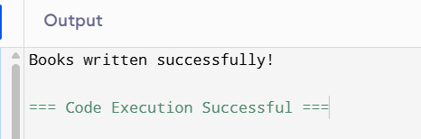

LAB TASK#02
Code:
System.out.println("\nReading books from file\n");

try (ObjectInputStream in = new ObjectInputStream(new FileInputStream("BookStore"))) {
while (true) {
Book b = (Book) in.readObject();
System.out.println("Book Name: " + b.name);
System.out.println("Publisher: " + b.publisher);
System.out.println("Author: " + b.author.name);

}
} catch (EOFException ex) {
System.out.println("End of file reached.");
} catch (ClassNotFoundException | IOException ex) {

}
}
OUTPUT:
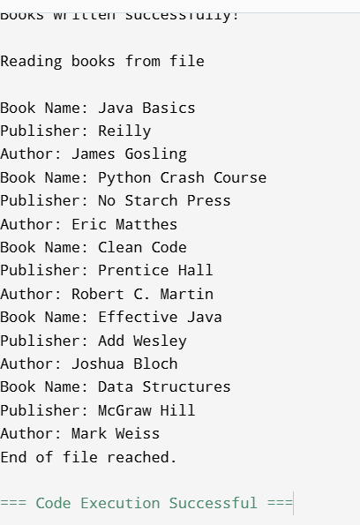
LAB TASK 3
public static void main(String[] args) {
Scanner sc = new Scanner(System.in);
String fileName = "BookStore";
writeBooks(fileName);
System.out.print("\nEnter the name of the book to search: ");
String bookName = sc.nextLine();
searchBook(fileName, bookName);
}
}
OUTPUT:
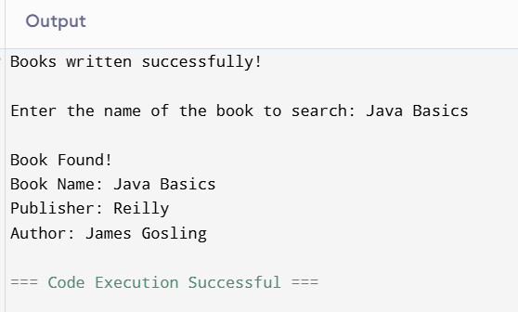

LAB TASK#04
import java.io.*;
import java.util.*;

class Account implements Serializable {
int accountNumber;
String accountHolder;
double balance;

public Account(int accountNumber, String accountHolder, double balance) {
this.accountNumber = accountNumber;
this.accountHolder = accountHolder;
this.balance = balance;
}
}

public class Main {

private static final String FILE_NAME = "Accounts.dat";

public static void createAccounts() {
try (ObjectOutputStream out = new ObjectOutputStream(new FileOutputStream(FILE_NAME))) {
out.writeObject(new Account(1001, "Alice", 5000));
out.writeObject(new Account(1002, "Bob", 3000));
out.writeObject(new Account(1003, "Charlie", 7000));
out.writeObject(new Account(1004, "David", 6000));
out.writeObject(new Account(1005, "Eve", 4500));
out.writeObject(new Account(1006, "Frank", 8000));
out.writeObject(new Account(1007, "Grace", 2000));
out.writeObject(new Account(1008, "Hannah", 3500));
out.writeObject(new Account(1009, "Ivy", 9000));
out.writeObject(new Account(1010, "Jack", 1000));
System.out.println("Accounts created successfully!");
} catch (IOException e) {
e.printStackTrace();
}
}

public static List<Account> readAccounts() {
List<Account> accounts = new ArrayList<>();
try (ObjectInputStream in = new ObjectInputStream(new FileInputStream(FILE_NAME))) {
while (true) {
accounts.add((Account) in.readObject());
}
} catch (EOFException e) {
// End of file reached
} catch (IOException | ClassNotFoundException e) {
e.printStackTrace();
}
return accounts;
}

public static void saveAccounts(List<Account> accounts) {
try (ObjectOutputStream out = new ObjectOutputStream(new FileOutputStream(FILE_NAME))) {
for (Account acc : accounts) {
out.writeObject(acc);
}
} catch (IOException e) {
e.printStackTrace();
}
}

public static Account findAccount(List<Account> accounts, int accNo) {
for (Account acc : accounts) {
if (acc.accountNumber == accNo) {
return acc;
}
}
return null;
}

public static void withdraw(List<Account> accounts, Scanner sc) {
System.out.print("Enter account number: ");
int accNo = sc.nextInt();
Account acc = findAccount(accounts, accNo);
if (acc != null) {
System.out.print("Enter amount to withdraw: ");
double amount = sc.nextDouble();
if (amount <= acc.balance) {
acc.balance -= amount;
System.out.println("Withdrawal successful! New balance: " + acc.balance);
} else {
System.out.println("Insufficient balance.");
}
} else {
System.out.println("Account not found.");
}
}

public static void deposit(List<Account> accounts, Scanner sc) {
System.out.print("Enter account number: ");
int accNo = sc.nextInt();
Account acc = findAccount(accounts, accNo);
if (acc != null) {
System.out.print("Enter amount to deposit: ");
double amount = sc.nextDouble();
acc.balance += amount;
System.out.println("Deposit successful! New balance: " + acc.balance);
} else {
System.out.println("Account not found.");
}
}

public static void transfer(List<Account> accounts, Scanner sc) {
System.out.print("Enter sender account number: ");
int senderNo = sc.nextInt();
Account sender = findAccount(accounts, senderNo);
if (sender == null) {
System.out.println("Sender account not found.");
return;
}

System.out.print("Enter receiver account number: ");
int receiverNo = sc.nextInt();
Account receiver = findAccount(accounts, receiverNo);
if (receiver == null) {
System.out.println("Receiver account not found.");
return;
}

System.out.print("Enter amount to transfer: ");
double amount = sc.nextDouble();
if (amount <= sender.balance) {
sender.balance -= amount;
receiver.balance += amount;
System.out.println("Transfer successful!");
} else {
System.out.println("Insufficient balance in sender account.");
}
}

public static void balanceInquiry(List<Account> accounts, Scanner sc) {
System.out.print("Enter account number: ");
int accNo = sc.nextInt();
Account acc = findAccount(accounts, accNo);
if (acc != null) {
System.out.println("Account Holder: " + acc.accountHolder);
System.out.println("Balance: " + acc.balance);
} else {
System.out.println("Account not found.");
}
}

public static void displayAllAccounts(List<Account> accounts) {
System.out.println("\n--- All Accounts ---");
for (Account acc : accounts) {
System.out.println("Account Number: " + acc.accountNumber +
", Holder: " + acc.accountHolder +
", Balance: " + acc.balance);
}
}

public static void main(String[] args) {
Scanner sc = new Scanner(System.in);

File f = new File(FILE_NAME);
if (!f.exists()) {
createAccounts();
}

List<Account> accounts = readAccounts();

while (true) {
System.out.println("\n ATM Menu is folowing ");
System.out.println("1. Withdraw");
System.out.println("2. Deposit");
System.out.println("3. Transfer");
System.out.println("4. Balance Inquiry");
System.out.println("5. Display All Accounts");
System.out.println("6. Exit");
System.out.print("Choose option: ");
int choice = sc.nextInt();

switch (choice) {
case 1:
withdraw(accounts, sc);
break;
case 2:
deposit(accounts, sc);
break;
case 3:
transfer(accounts, sc);
break;
case 4:
balanceInquiry(accounts, sc);
break;
case 5:
displayAllAccounts(accounts);
break;
case 6:
saveAccounts(accounts);
System.out.println("Thank you for using ATM!");
return;
default:
System.out.println("Invalid option. Try again.");
}
}
}
}
OutPUT:
